1.95: The receiver's position is

The vector from the quarterback to the receiver is the receiver's position minus the quarterback's position, or 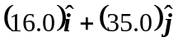, a vector with magnitude 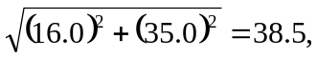given as being in yards. The angle is 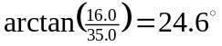to the right of downfield.

